Fig. 1: Pallet Label Example
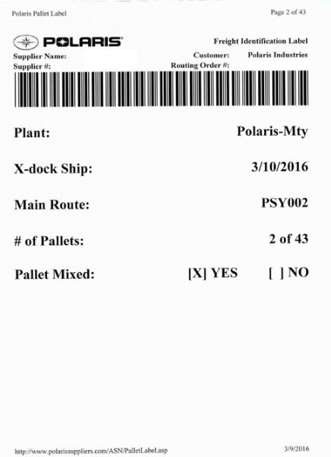
Fig. 2: Pallet Label Data Structure
DATA ELEMENT | DESCRIPTION | EDI DETAILS (if applicable)
Routing Order # | Unique # for route and stop | 862 TD505
Barcode | Concatenation of ‘R’, routing order number, and pallet number (example: “R10823451078987-001” where 001 is pallet 1 of 42 for a 42 pallet lot)
Plant | Polaris Ship To City, State | 850/860 Ship To
X-dock Ship | Final Delivery ship date - date goods need to leave x-dock | 862 DTM02 when DTM01 = 011
Main Route | Final delivery route (x-dock to plant route) | 862 REF04.4
# Pallets | Pallet count (# of current pallet out of total pallet lot)
Pallet Mixed | Defines mixing for this pallet lot. Supplier needs to print correct number of labels marked Yes and No and affix correctly.

